Issue 1 News and Notes Fall 2019

Welcome to this newsletter of The Foundation. With it we want to provide periodic highlights and updates of Foundation activities and ways The Foundation is serving the Conference. As you have ideas and suggestions, please feel free to share them with us at 419 425 9602 or FoundationDirector@cggc.org.

Grants for the Greater Good
In the Spring of 2019, The Foundation awarded $226,480 through 15 grants, four to local churches, two to Camp Otyokwah and nine to the Executive Board and commissions of the Great Lakes Conference (GLC). Several of the GLC grants will create opportunities for participation by individuals across the Conference:

A clergy couple retreat will be held in the spring to support clergy marriages.

The Foundation will pay one third of the tuition for GLC students to take classes at Winebrenner Seminary.

A workshop to help congregations provide ministry to those who struggle with addictions will be held later this year.

Funding is made available for five congregations to develop an internship program.

Scholarships will be provided to ten pastors to attend a leadership conference.

Each of these initiatives is larger than the local church. As you have opportunity to participate, please contact the Conference office (419 423 7694, glcdirector@cggc.org).
Preliminary Grant Requests
The grant making cycle begins with congregations and affiliated agencies of the Great Lakes Conference filing a preliminary grant request with The Foundation. Preliminary requests are due in the Foundation office not later than January 6, 2020. A Guideline for Grant Seekers and the Preliminary Grant Request Form can be found on The Foundation’s website, www.FoundationGLC.org. Questions may be directed to the president by phone (419 425 9602) or email (FoundationDirector@cggc.org).

Transformative Grants
The Foundation is especially interested in receiving requests for grants that transform ministry. These are program opportunities that enable congregations and affiliates more effectively to change lives, to work out God’s will on earth as it is in heaven (Mt 6:10). Examples of transformative grants could include hosting a training event to deal with addictions, participating in a learning community, piloting an outreach activity in the community, or providing a healing care ministry for veterans. These are ministries and programs that directly impact individual lives with the Gospel.
Foundation Board Meeting
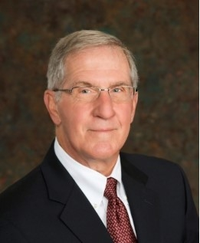
The Foundation Board of Directors meets next on November 7, 2019, and will include a time of strategic planning in its order of business. Paul Worstell, CEO of the Findlay YMCA, will help the board reflect on mission, vision, values, strategic initiatives and operational goals for this next season of service to the Conference.

Estate Planning Workshop
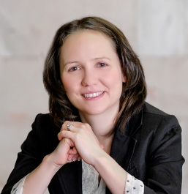
The Foundation will host an hour-long estate planning workshop on September 30, beginning at 7:00 pm at the Celina First Church of God. Led by Sarah J. Corney, an attorney who worshiped with Pastor Craig Flack before he joined the GLC, the seminar will focus on the basics of planning for our people and property when we have passed. If you live near Celina, we would encourage you to take advantage of this workshop. And if you would like to hold a similar workshop, please contact the Foundation.
Planned Giving Ideas
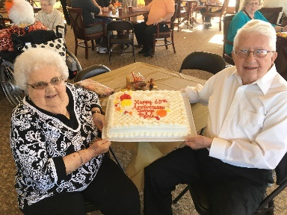
Recently Pastor Mills in the Great Lakes Conference office received a note from Kay McClure, executrix of her parent’s estate. George and Marie Conrad had been married for 65 years and were active in the Home Acres/ Pathway congregation.

Through their estate they chose to remember Winebrenner Seminary, the medical ministry in Haiti and the Pop Tewell Scholarship at Camp Otyokwah. Kay’s letter to Pastor Earl speculated on some of the reasons that her Mom and Dad remembered these three ministries: because the Seminary provided quite a few pastors for Home Acres “right after graduation;” because “Pastor Jim Wallace and his family served Home Acres before beginning their ministry in Haiti” and the congregation continued to support Dr. Vic and Donna Binkley; and because a whole family was blessed by the ministry at Camp Otyokwah and specifically Pastor Tewell served at Home Acres, “and we all knew, loved and respected him. To help give other children the opportunity to be blessed through this special place like we were is an appropriate memorial gift to honor George and Marie.”

Thank you so much, Kay, for sharing the loves of your parents and for acknowledging their wish to support ministries of the Churches of God with an estate gift. This is a wonderful way to extend our outreach. If you would like more information on making an estate gift, contact your attorney or call The Foundation.

Stewardship Moment
Why do you give? When the plate is passed, when you send a check to your favorite ministry, when you offer cash to someone in need, why do you do it?

Sometimes we give in response to a need, as our hearts are touched by the picture of a hungry child.

Sometimes we are captivated by a vision, as a woman and her husband gave up their vacation to support the congregation’s church renovation project, or a donor signed on to a seven figure gift when he learned how ministry in the new building would touch unchurched families.

Sometimes we respond to a relationship built by people in the congregation who genuinely care, who share hope and a conviction that the Father will not let us go or let us down.

Sometimes we give because we have been taught to give, learning that while everything belongs to God, he specifically asks us to return 10% of our income to him.

Sometimes we give out of simple obedience, because Jesus challenges us (Lk 6:38) and we choose to be faithful.

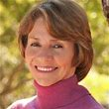
Lynne Twist writes of raising money to alleviate hunger. She had accepted an invitation to speak at a church in Harlem. But before that encounter she was invited to the penthouse office of a huge food company with an image problem. The CEO handed her a check for $50,000 and dismissed her with no interest in the project. She felt as if this were only a transaction to placate his or the company’s guilt.

When she got to the basement of the Harlem church building, she found a group of 75 parishioners and told her story. One listener was an elderly woman who said, “Girl, I like what I’ve heard. I ain’t got no checkbook or credit card, but to me, money is like water: for some it rushes through life like a raging river; for me, it’s a little trickle. But I want to pass it on in a way that it does the most good for the most folks. I see that as my right and my responsibility. And my joy. I have $50 I earned doing a white woman’s laundry. I want to give it to you.”

She gave Lynne a fistful of bills and a big hug. Then came others. Lynne couldn’t hold it all and opened her briefcase. They dropped in their gifts, $500 worth. And there seemed to be a sense of integrity, warmth, heart and self. Lynne wrote, “Gertrude taught me that the power of money is really derived from the intention we give it and the integrity we direct it into the world.”

Intentionality and integrity! Jesus made much of a woman who dropped two copper coins into the temple treasury (Mk. 12:41ff.). He honored her with an affirmation that she gave more than all the others.

We give because we choose to honor the Lord by making a difference for the sake of others. May He bless you with the gift of generosity as you touch lives for His sake!

