Issue 2 News and Notes Winter 2019

Foundation Board Meeting
At its meeting on November 7, The Foundation Board of Directors recognized Randy Dammeyer of Celina for his nine years of excellent service as a Director. At the end of this calendar year, Randy completes three full three-year terms and is required to step off the board for at least one year. He will be succeeded by Dan Kennard of Findlay who returns to the Board after an eight-year absence.

Financial Controller, Bob Stephenson, reported that on October 31, 2019 the Foundation had $8,051,946 in total assets. That includes about $800,000 in Investment Facilitator Agreements, $200,000 in liabilities and restricted assets, and just under $7 million in unrestricted assets. Four percent of those unrestricted assets on a three-year rolling average is made available for grant distribution each year.

The Board adopted a policy permitting The Foundation to create Donor Advised Funds. A Donor Advised Fund permits a donor to transfer an irrevocable asset to the Foundation, receive an income tax deduction in the current year, and distribute in current and/or future years.

As part of its strategic planning process the Board adopted a strategy and plan that will guide its work for the next five years:

MISSION
To stimulate life-changing ministry.

VALUES
Discipleship – Transform lives through Jesus.
Generosity – Nurture stewardship and sacrifice.
Creativity – Turn new and imaginative dreams into reality.

VISION
- Increase ministry resources
- Inspire and equip forward and/or outward thinking
- Teach generosity
- Cultivate a new generation of leadership
- Award transformative grants
- Multiply service in the Kingdom

STRATEGIC THEMES AND 2020 OPERATIONAL GOALS:
Increase ministry resources
- Meet with potential donors
- Sponsor estate planning workshops
- Increase assets
Stimulate ministry
- Produce quarter newsletters
- Connect with the senior pastor of each church in the GLC
Cultivate next generation leadership
- Facilitate next generation grants
Preliminary Grant Requests
Preliminary grant requests are due in the Foundation office on January 6, 2020. The Preliminary Grant Request Form along with the document Guideline for Grant Seekers can be found on The Foundation’s website, www.FoundationGLC.org. No grant is awarded without this completed form being submitted by the deadline. Applicants will be notified by February 1 whether they are approved to proceed with a formal application. Grants are approved at the May 14 Board of Directors meeting for distribution after June 1. Questions may be directed to the president by phone (419 425 9602) or email (FoundationDirector@cggc.org).

Grants for the Greater Good
At the November Board meeting, the Directors took action to award $30,000 as an initial commitment toward a three-year initiative of the Executive Board to develop leaders. Called the Leadership Fellowship Initiative, the grant will supplement a residency with a teaching church along with theological education at Winebrenner Seminary for three fellows over a three-year period. The initiative is designed to recruit and prepare leaders for the Churches of God and to identify and resource teaching churches who can serve as incubators for leadership development.

Planned Giving Ideas
Required Minimum Distribution (RMD)

Individuals with traditional IRAs and/or retirement plans are required to begin withdrawing a minimum amount each year when they turn 70 1/2. With certain exceptions those withdrawals are generally reported as taxable income.

The Internal Revenue Service permits an RMD to be distributed directly to a charitable organization, avoiding any taxable liability.

This fall The Foundation was the beneficiary of a portion of a donor’s RMD. That gift will be added to net assets and with the Total Net Assets Without Donor Restrictions, be made available for annual distribution.

If The Foundation can serve you with regard to an RMD, please contact us by phone (419 425 9602) or email (FoundationDirector@cggc.org).

Merry Christmas
On behalf of the Board, Bob and I wish you a joyous and meaningful Christmas celebration. We trust that in this busy season, you may slow enough to experience the inbreaking of our gracious God into this world and into your life.

May you have a blessed and joyous Christmas.

Bill Reist, President
Bob Stephenson, Controller
Stewardship Moment
I write this on the back side of a profound visit to prison. For the past several years Winebrenner Seminary has been offering classes with inmates at Marion 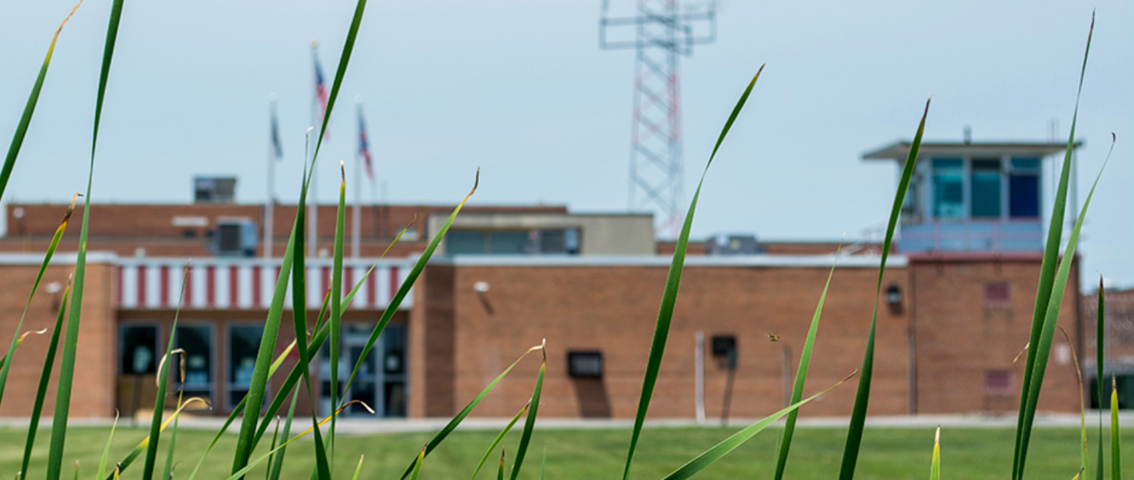Correctional Institution. The first cohort has completed the program and graduated from Winebrenner with a pastoral training certificate. Five of the candidates requested credentials to continue their ministry. Dr. Mills and members of the Pastoral Life Commission interviewed those candidates and found that they not only successfully completed their academic studies, but also participate in significant, authentic, life-changing gospel ministry. These five independently lead and teach multiple small groups and Bible studies as well as mentor and shape the lives of numerous inmates.

What struck me as I listened to their stories was the word incarnation, derived from the Latin root caro (flesh): “made flesh,” referring to God becoming flesh and dwelling among humankind (Jn 1:14). The Message paraphrases the verse, The Word became flesh and blood and moved into the neighborhood. In its most general sense incarnation refers to dwelling among or taking up residence among others, not as visitor but resident. God became flesh and moved in with us.

These five inmates may not have chosen to be in prison. But now that Jesus has seized their lives, they are doing all that they can where they are to help others experience new life in Christ.
Several years ago I was part of a collection of weekend ministry teams that spent two days in prison, sharing the Gospel. In retrospect, I imagine that my prison visits shaped my life far more than my witness shaped any inmate. In fact, the inmates remarked this past weekend that when outsiders visit to share the Gospel, inmates will ask trusted peers whether the message is real. Incarnation: entering a world, pitching a tent, staying a while, building trust, pointing to new life.

I spoke with someone recently who referenced her key three: three significant organizations where she invests time, leadership and financial support. She is committed to those three in a way that is not diluted by scattered focus. She enters the world of these organizations and is all-in for the long haul.

My recent experience in prison, coupled with the season of Advent, challenges me to meditate again on incarnation: God becoming flesh and dwelling among us. And I rejoice that Jesus chose willingly to enter our world to deliver us from the sin and brokenness in which we live.

But the Gospel also invites us to ask where and how we practice incarnation: where we are willing to invest deeply both time and treasure in those few but important arenas that will make a difference in the name of Jesus for those who may not yet know him.

In this Christmas season, reflect again on your use of time and treasure so that you may serve in the Kingdom with an all-in, incarnate spirit.

Pastor Bill

