Issue 13 News and Notes Fall/Winter 2022

October Board Meeting
The Foundation Board reports several significant issues from its most recent meeting:

- Awarded 16 grants in the amount of $342,732 during the current year.
- Supported Camp Otyokwah in the purchase of property bounded by the camp.
- Received an endowment from the Great Lakes Conference (GLC) funded by the Conference’s share of the proceeds from the recently dissolved Larry G. White Trust.
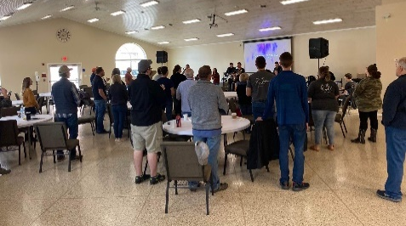
- Honored Lance Finley who completes three terms as a director and is ineligible to be renominated; also, honored Earl Mills as an ex officio member of the Board on his retirement as Executive Director of the GLC after eleven years of service.
- Nominated Eric Baltzell from Celina First as a potential board member; Eric was subsequently elected by the GLC Executive Board to a term beginning January 1, 2023.
- Welcomes Dave Odegard who will serve ex officio as Executive Director of the GLC.
- Reaffirmed the micro grant strategy, adding the provision that multiple grant requests not to exceed $5,000 each may be received from the same congregation in the same year.
Preliminary Grant Requests
Preliminary Grant Requests for 2023 are due in The Foundation Office on Monday, January 30, at 3:00pm. Request forms and Guidelines are available on the website (www.foundationglc.org) or by contacting the office.

Grants at Work
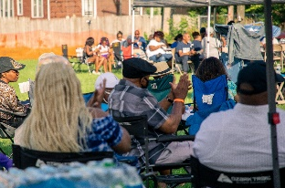
Wharton hosted a worship seminar led by the worship team from Grand Point Church (Eastern Regional Conference). Six worship teams were represented at the conference which included a Friday evening worship experience and Saturday workshops. The most meaningful take-away was a deeper appreciation for the vertical, God-focused nature of Christian worship that results in a richer and more biblical worship experience.

Ridgeway replaced the carpet in their Fellowship Hall/Gym. The facility hosts a wide range of community and church activities throughout the week, including a local group of pastors who play basketball early on Friday mornings, various coaches whose teams practice throughout the season, and community meals.
Word Encounter sponsored a multicultural “Jazz on the Grass” experience this past summer for their local ministry area in northeast Detroit. The afternoon included music and food but most importantly, gave opportunity for unifying the community by neighbor meeting neighbor, and awareness of the church as a powerful resource in the community. Nearly 300 people attended with over 150 households represented. The church plans to host the event again next year.

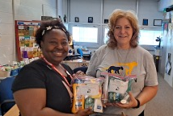
Kingdom Community Christian Ministries distributed 400 hygiene kits to children through seven Toledo Public Schools. The project met a need among the schools as one nurse called for assistance and several nurses shared their gratitude on social media. KCCM hopes to continue the ministry by applying for another micro grant next year.
Year End Giving
For the past several years The Foundation has received contributions totaling over $250,000 from multiple donors to support our work. We deeply appreciate this commitment to our mission of “stimulating life-changing ministry” and are grateful to be able to encourage congregations, the Executive Board, and Camp Otyokwah in sharing the Good News of Jesus.

As a 501(c)3 tax exempt organization we receive cash gifts, appreciated stock, direct transfers from certain tax-qualified or retirement plans, and planned gifts through an estate. The “Give” button on the website will enable individuals to give current gifts electronically. Do not hesitate to contact the office by phone or email at the addresses below if you would like more information.

A Stewardship Meditation
Christmas Memories
As a kid I remember hiding behind
an overstuffed chair on Christmas Eve with my next-oldest brother
as we watched our parents carry

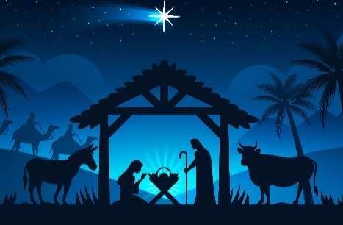
This News and Notes is brought to you by The Foundation of the Great Lakes Conference, 700 East Melrose Avenue, Findlay, OH 45840 and its staff, William Reist, President, and Robert Stephenson, Financial Controller. We trust that you will have a joyous Christmas and continue to celebrate the wondrous birth of our Savior. For more information contact us at foundationdirector@cggc.org, call (419) 425-9602 or (419) 957-2661, or visit us at www.foundationglc.org.
out and wrap gifts for the next morning. We had been hoping for a race car set and soon discovered we would not be disappointed. But then the awkward moment of truth: it would take Mom and Dad quite a while—maybe more than an hour—to finish wrapping gifts for four boys. And while we were excited, we were tired and wanted to sleep. But how to escape our hiding place undetected? All I remember from the rest of the experience is that we made it up the stairs and back to our bedroom without any response from our parents. If Mom and Dad knew of our sneaking, they never let on. But the gift would bring these young boys great joy.

Years later I proposed to Judy on a Christmas Eve. It was late in the evening, after I had led our congregation in Christmas Eve worship. Judy would still have to drive to her home. And I was more than excited throughout the evening that culminated in, She said, Yes!

And still later I reflected on an article on the commercialization of Christmas in which the author acknowledged the frantic and too-often debt-inducing spending of our culture, and then wondered what would have happened if God had taken that same attitude: I’ve given enough—land, temple, and all the rest; they don’t need anything more. But the gift of the Christ-child showed the full extent of his love, a sacrificial gift of unfathomable worth. At the time I had my eye on a ring to give to Judy and had debated on whether it was too much for this young husband’s budget. In the end, I gave. Several weeks ago I paid attention to Judy again wearing the ring I had given nearly 40 years before: a deep love shared. When our boys were in high school, we decided to surprise their mother with a woodworking project. Judy knew that something was going on in the basement. But she was forbidden to go there, until on Christmas morning she was asked to wait in another room while we brought the completed project to the living room, under wraps, complete with bow. To her great surprise she uncovered an entertainment center, crafted by the most important men in her life. In our judgment, the gift is priceless.

Now, on a much different note, I’ve been reading again the story of the Magi. They too brought gifts at great expense, fit for a King. But they were wily, these Magi, and did not believe everything the Jerusalem mafia told them. But even more, they were obedient to the God who led them in the first place. Tragically, their questions stirred up the maniacal and threatened Herod, and as a result blood was shed in Bethlehem and parents wept the vicious murder of their infant sons.

It's for both kinds of human experiences—these Christmas memories—that God came to visit Bethlehem: for both the joy of wonderous gift giving and love, as well as the pain and grief of human sin and brokenness. That Bethlehem visit led eventually to even more bloodshed, this time redemptive for all who believe: a Cross in which evil is confronted and death finally destroyed.

And so, we remember the ultimate and most important Gift given, to meet us both in our joy and in our sorrow. Thanks be to God for this his indescribable gift!

Pastor Bill

